H.T.No: 2303A51656
Batch 28
Set up Google Gemini API
To use the Gemini API, you'll need an API key. If you don't already have one, create a key in Google AI Studio.

In Colab, add the key to the secrets manager under the "🔑" in the left panel. Give it the name GOOGLE_API_KEY. Then pass the key to the SDK:

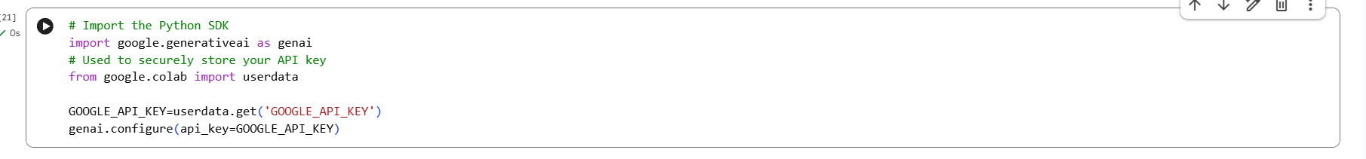
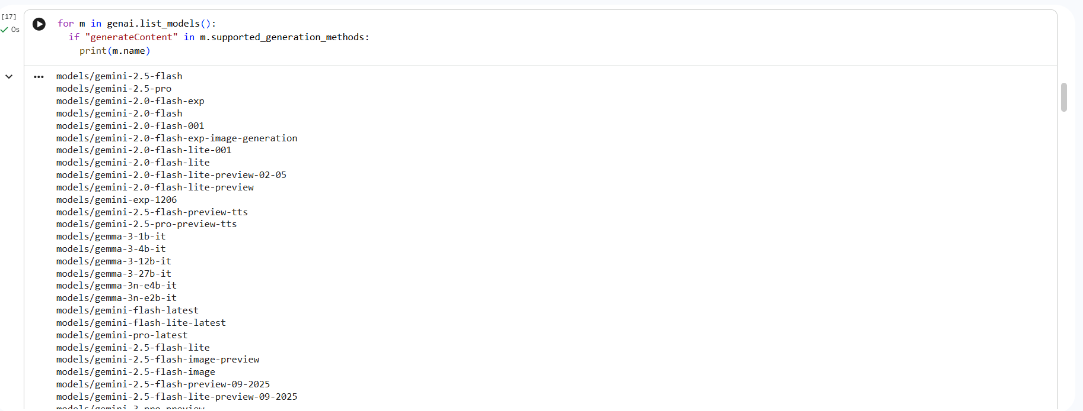
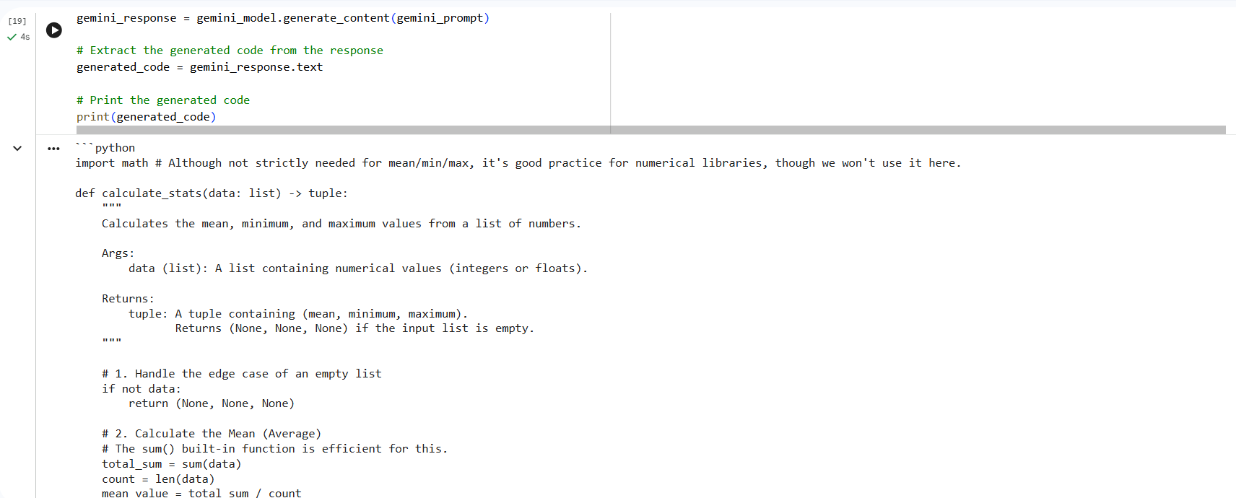
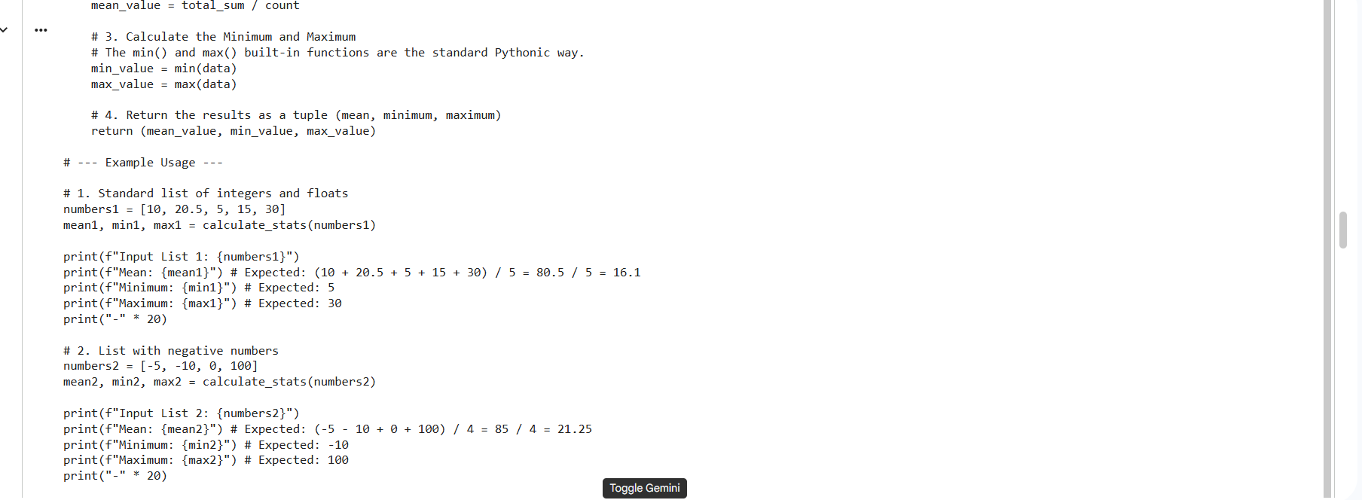
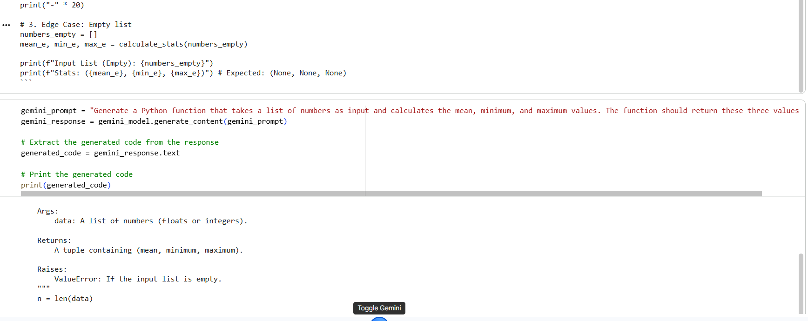
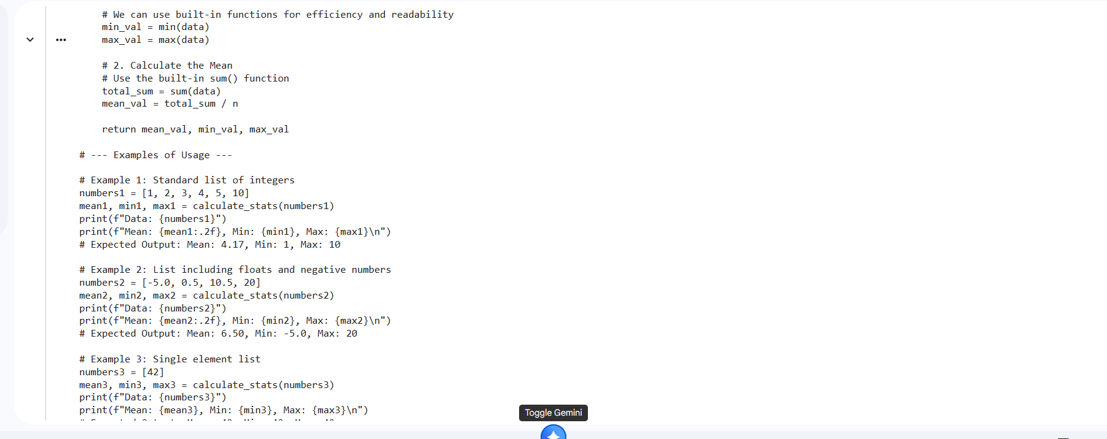
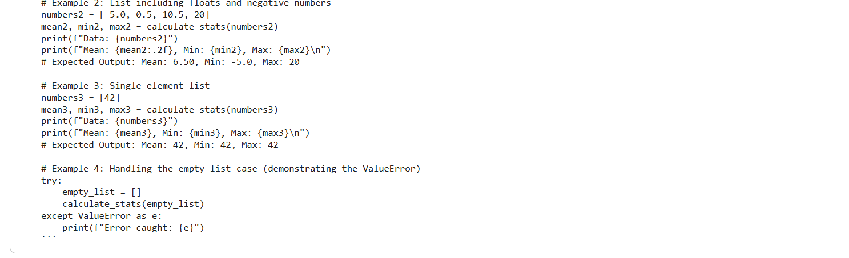
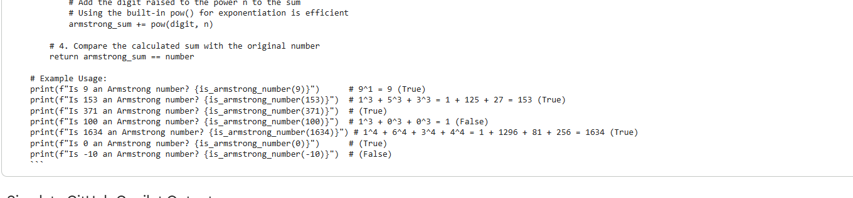
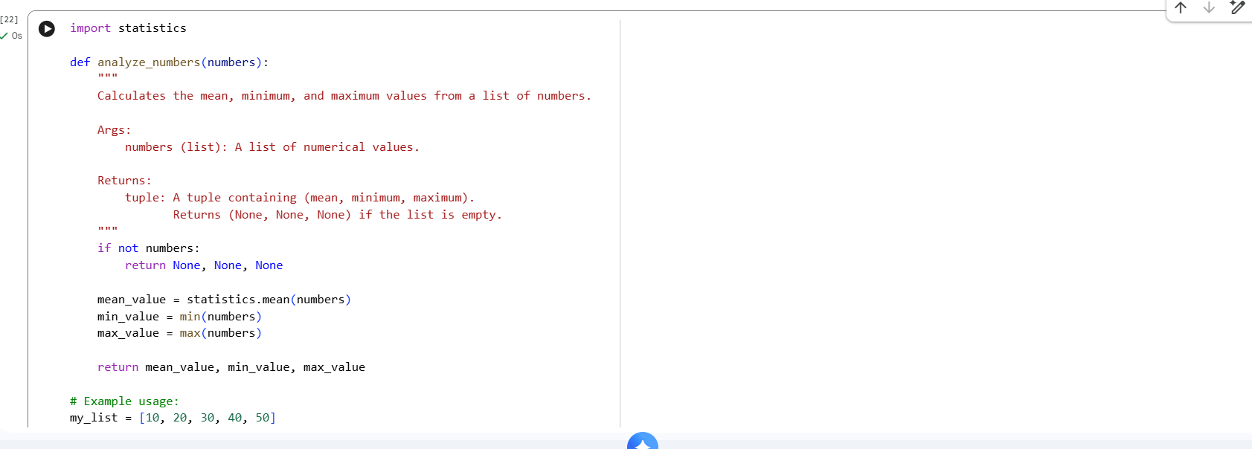
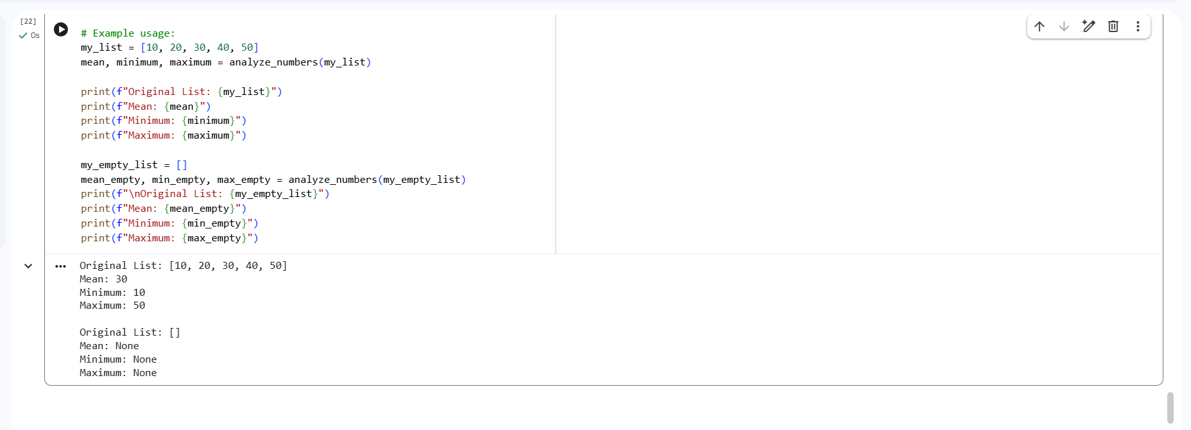

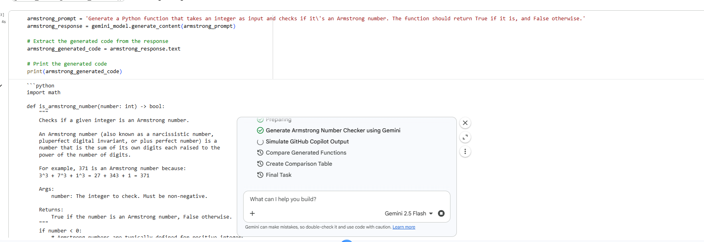
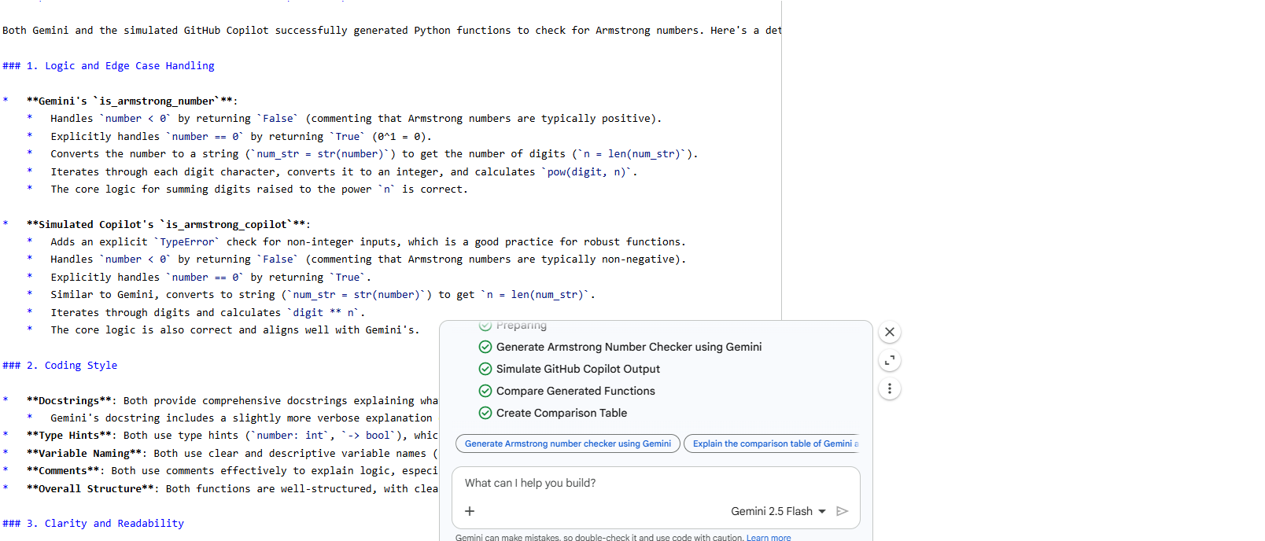
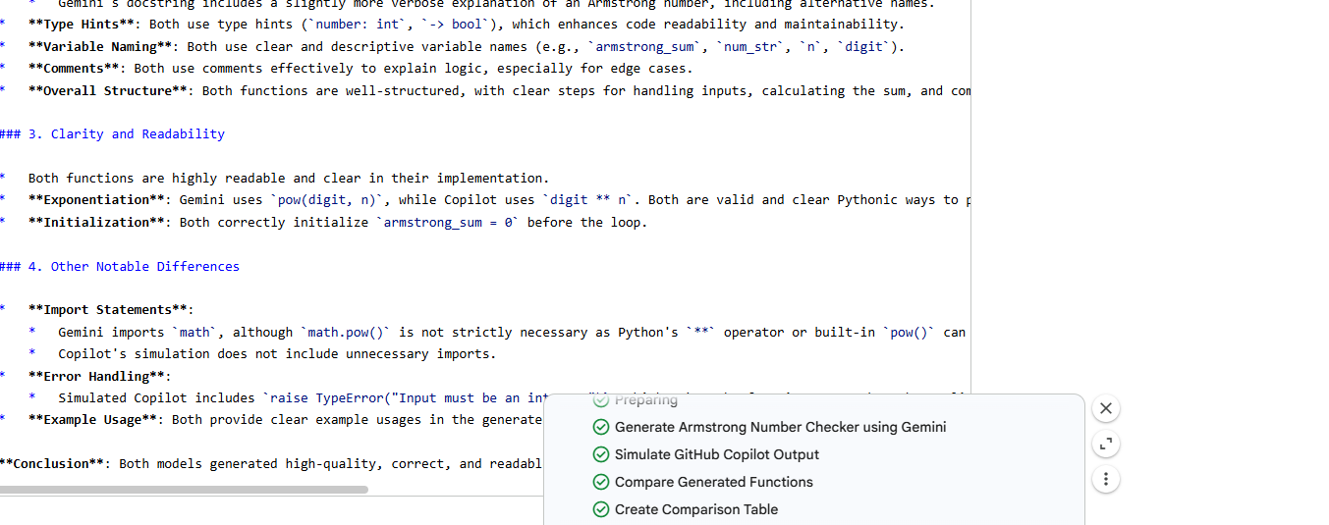
Before you can make any API calls, you need to initialize the Generative Model.
Now that the Gemini API is set up, I will use it to generate the Python function as requested. The prompt will be: Generate a Python function that takes a list of numbers as input and calculates the mean, minimum, and maximum values. The function should return these three values.
Task
Generate a Python function that checks if a number is an Armstrong number using the Gemini API.

Generate Armstrong Number Checker using Gemini
Subtask:
Use the already configured Gemini API to generate a Python function that checks if a number is an Armstrong number.

Reasoning: To generate the Armstrong number checker function, I will define a prompt string and then use the gemini_model.generate_content() method to get the generated code from Gemini.

Simulate GitHub Copilot Output
Subtask:
Provide a plausible Python function for an Armstrong number checker, simulating the output from GitHub Copilot. This will be used for comparison.

Reasoning: I need to generate a Python function is_armstrong_copilot that checks if a number is an Armstrong number, simulating the output style of GitHub Copilot. This includes docstrings, type hints, edge case handling, and example calls.

Compare Generated Functions
Subtask:
Analyze the Python functions generated by Gemini and the simulated GitHub Copilot for logic, style, clarity, and any other notable differences.

Comparison of Gemini and Simulated GitHub Copilot Outputs
Both Gemini and the simulated GitHub Copilot successfully generated Python functions to check for Armstrong numbers. Here's a detailed comparison based on the specified criteria:
1. Logic and Edge Case Handling
- Gemini's is_armstrong_number:
  - Handles number < 0 by returning False (commenting that Armstrong numbers are typically positive).
  - Explicitly handles number == 0 by returning True (0^1 = 0).
  - Converts the number to a string (num_str = str(number)) to get the number of digits (n = len(num_str)).
  - Iterates through each digit character, converts it to an integer, and calculates pow(digit, n).
  - The core logic for summing digits raised to the power n is correct.
- Simulated Copilot's is_armstrong_copilot:
  - Adds an explicit TypeError check for non-integer inputs, which is a good practice for robust functions.
  - Handles number < 0 by returning False (commenting that Armstrong numbers are typically non-negative).
  - Explicitly handles number == 0 by returning True.
  - Similar to Gemini, converts to string (num_str = str(number)) to get n = len(num_str).
  - Iterates through digits and calculates digit ** n.
  - The core logic is also correct and aligns well with Gemini's.
2. Coding Style
- Docstrings: Both provide comprehensive docstrings explaining what an Armstrong number is, the function's purpose, arguments, and return values.
  - Gemini's docstring includes a slightly more verbose explanation of an Armstrong number, including alternative names.
- Type Hints: Both use type hints (number: int, -> bool), which enhances code readability and maintainability.
- Variable Naming: Both use clear and descriptive variable names (e.g., armstrong_sum, num_str, n, digit).
- Comments: Both use comments effectively to explain logic, especially for edge cases.
- Overall Structure: Both functions are well-structured, with clear steps for handling inputs, calculating the sum, and comparing it to the original number.
3. Clarity and Readability
- Both functions are highly readable and clear in their implementation.
- Exponentiation: Gemini uses pow(digit, n), while Copilot uses digit ** n. Both are valid and clear Pythonic ways to perform exponentiation. There's no significant clarity advantage of one over the other in this context.
- Initialization: Both correctly initialize armstrong_sum = 0 before the loop.
4. Other Notable Differences
- Import Statements:
  - Gemini imports math, although math.pow() is not strictly necessary as Python's ** operator or built-in pow() can be used directly for integers. This might be a slight over-import or habit from general mathematical functions.
  - Copilot's simulation does not include unnecessary imports.
- Error Handling:
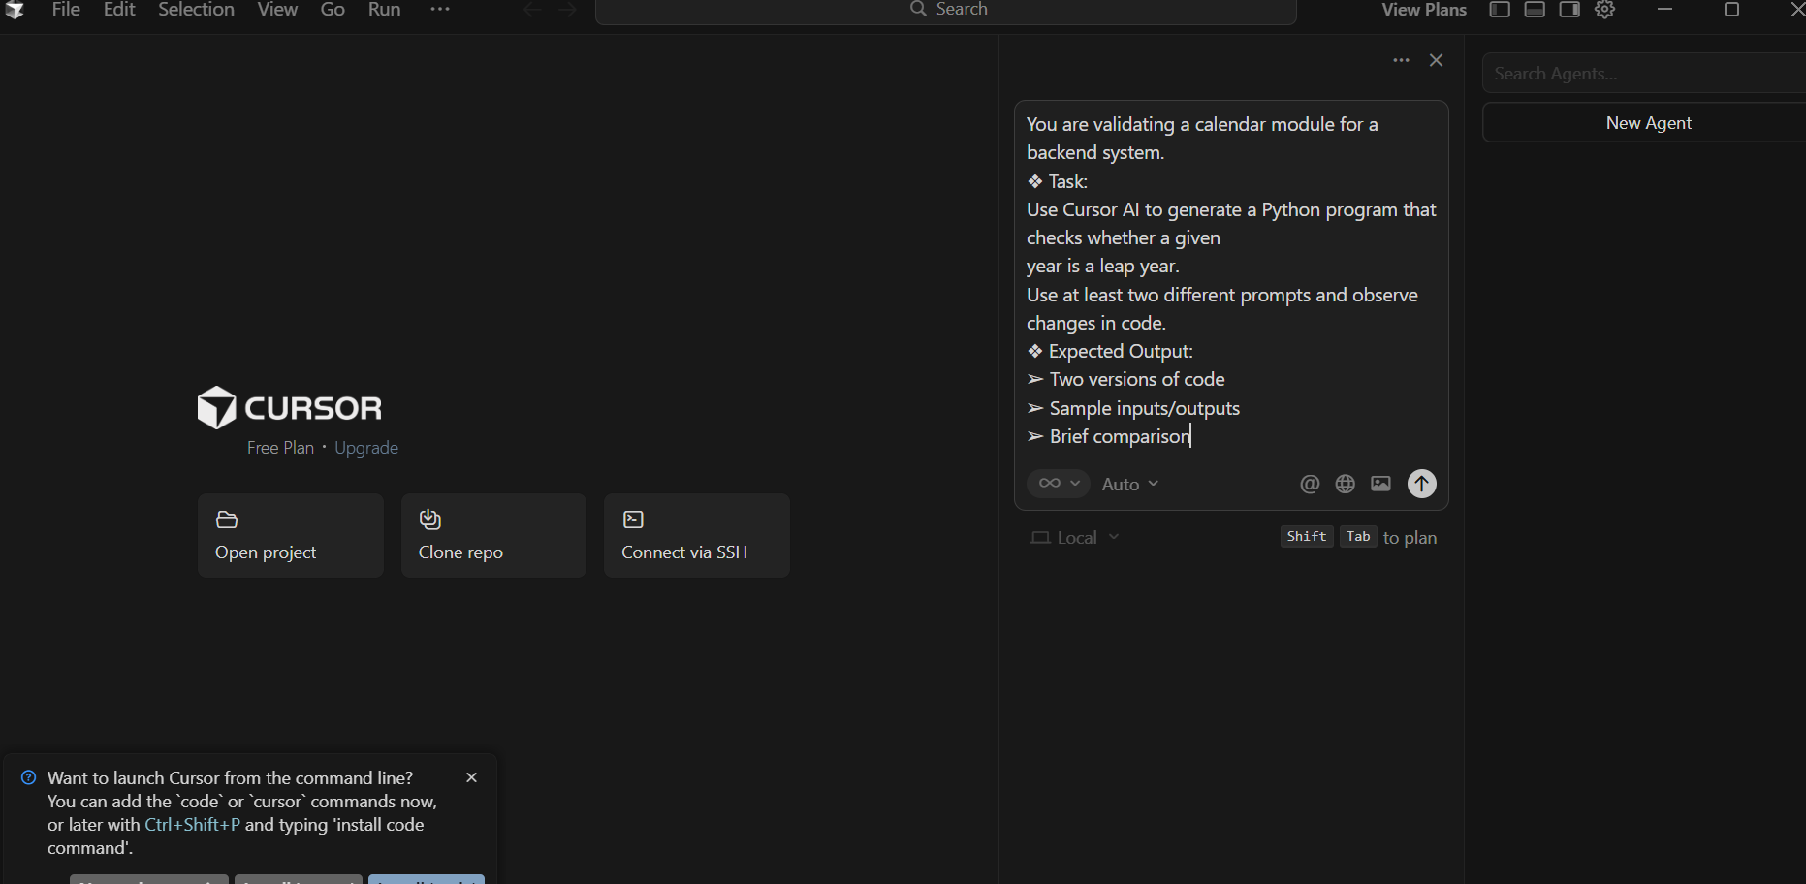
  - Simulated Copilot includes `raise TypeError()
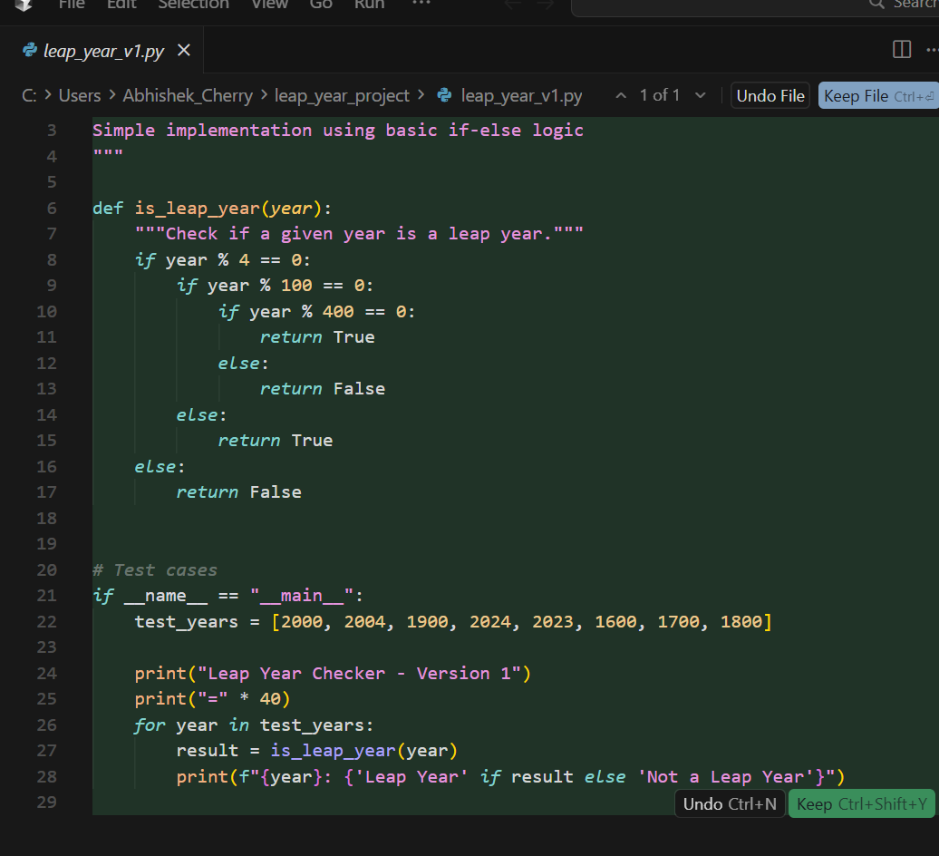
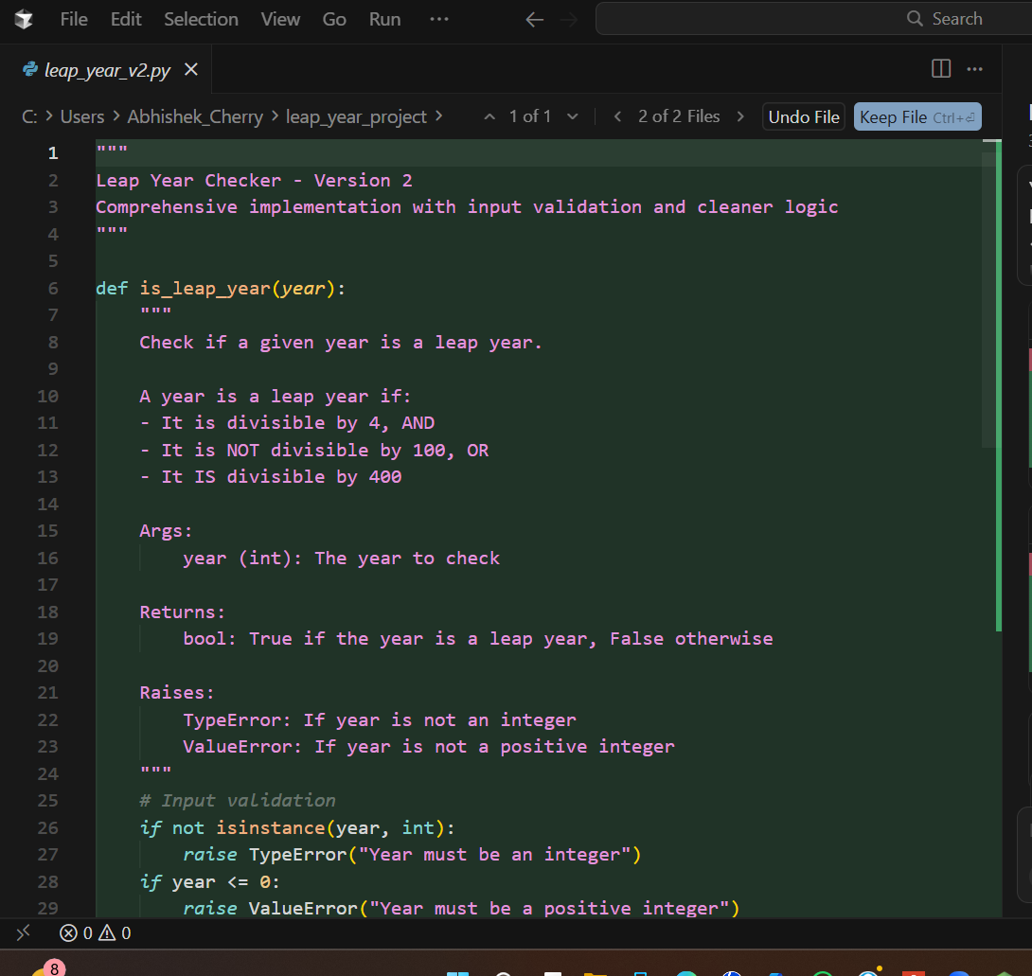
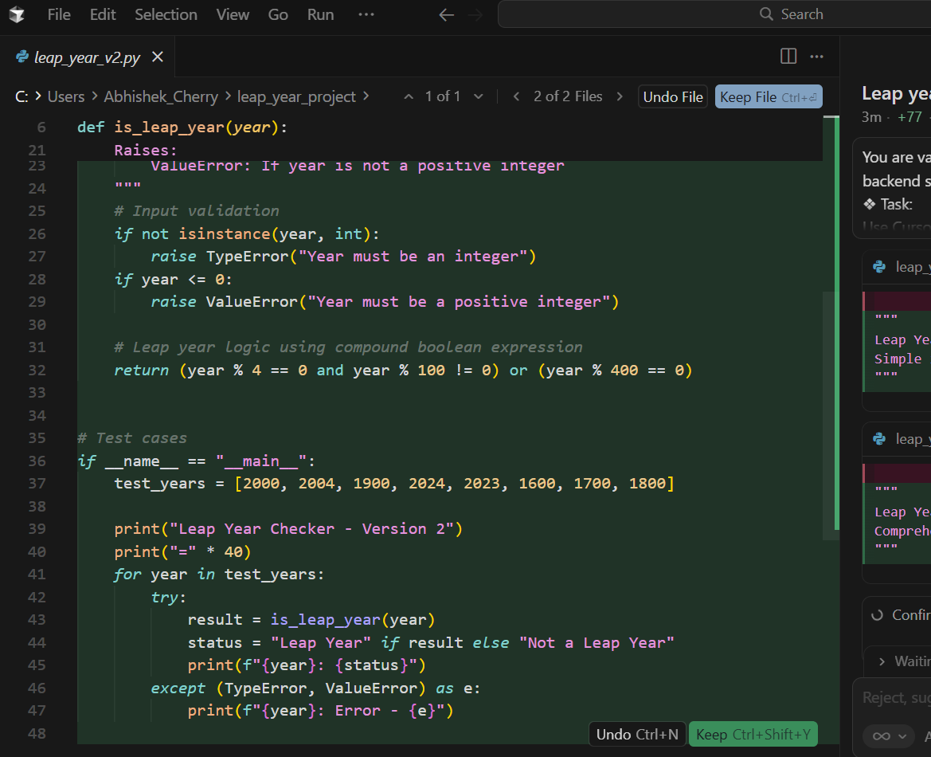
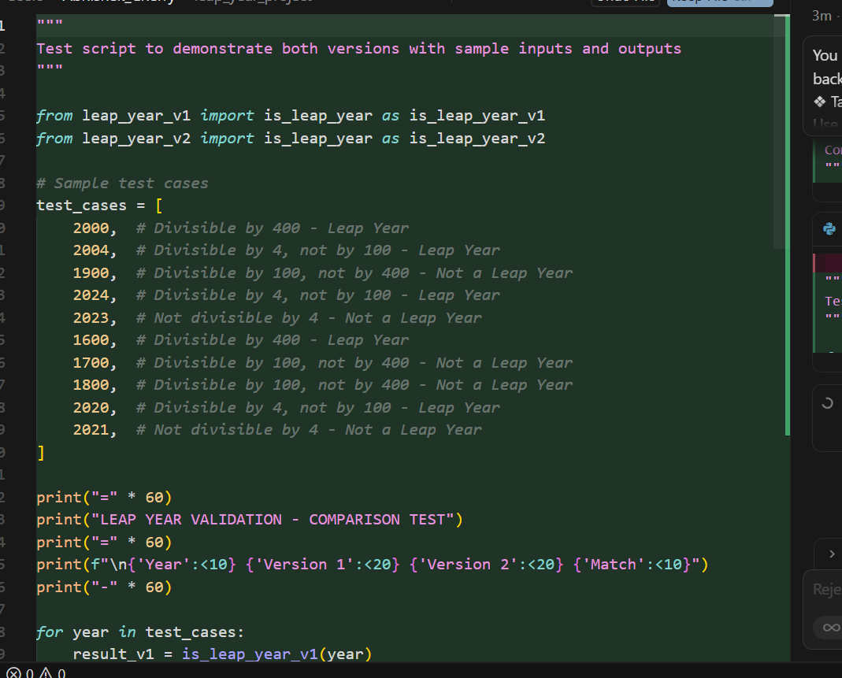
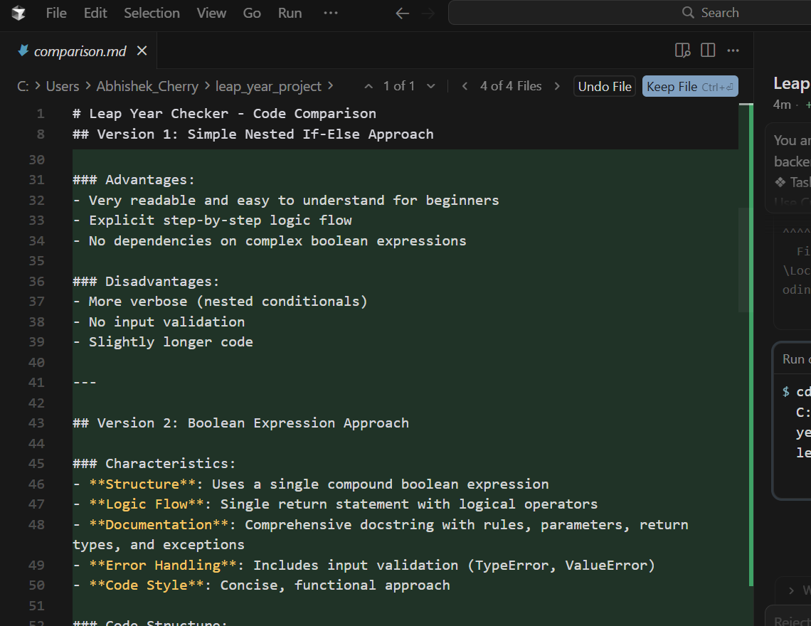
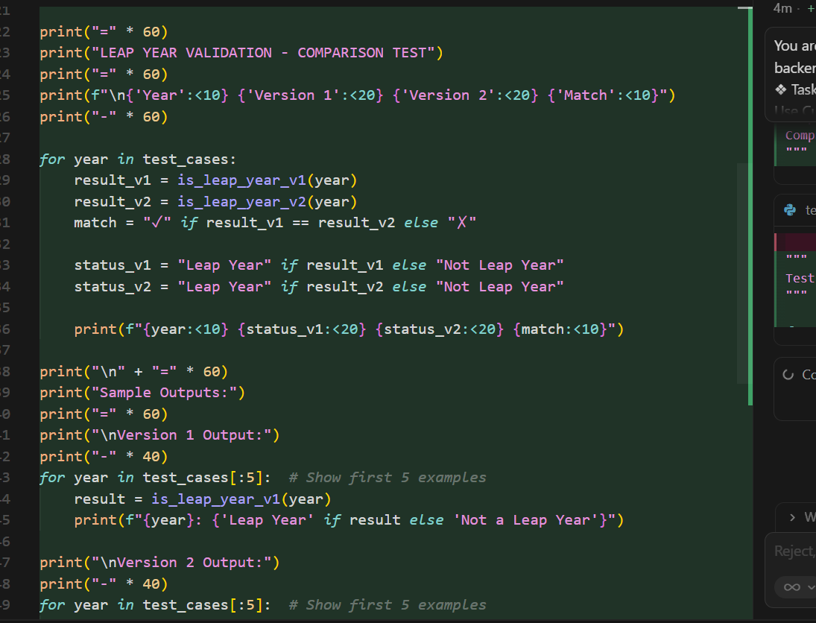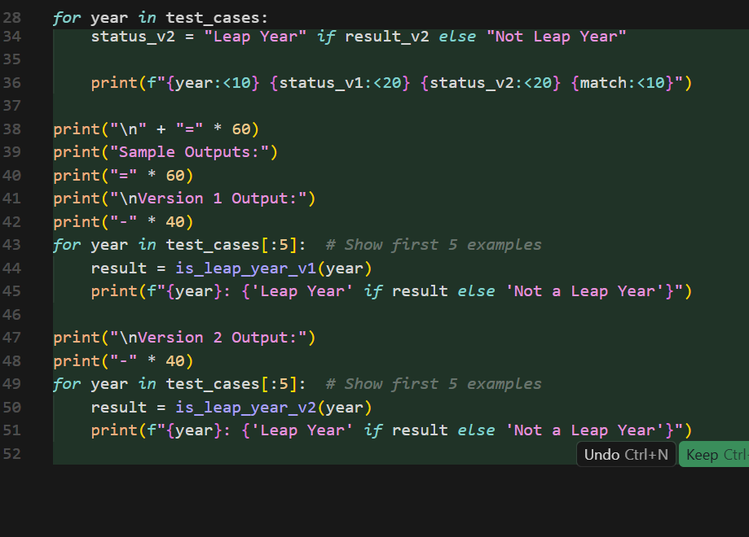
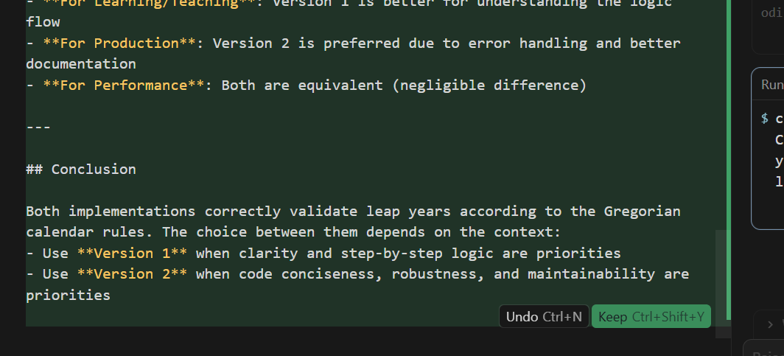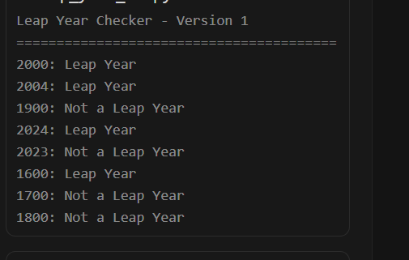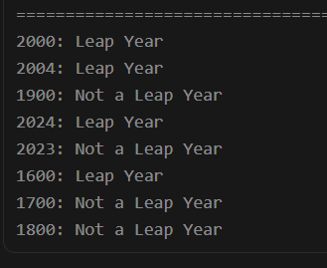
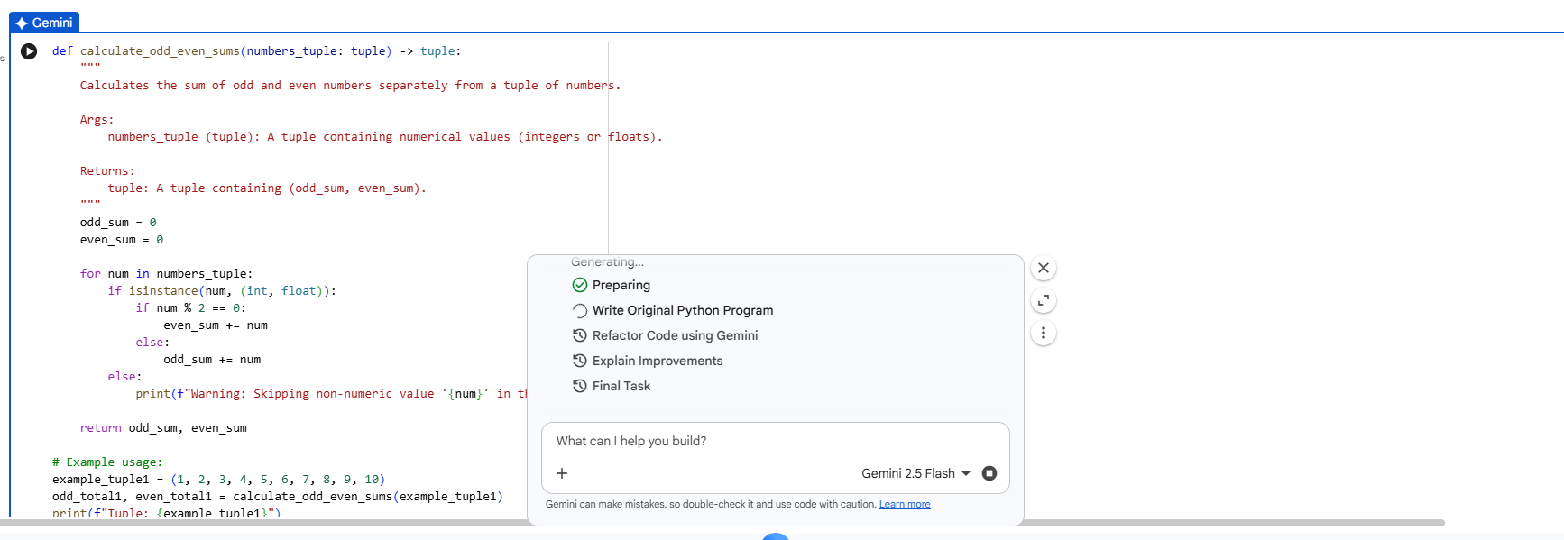

- 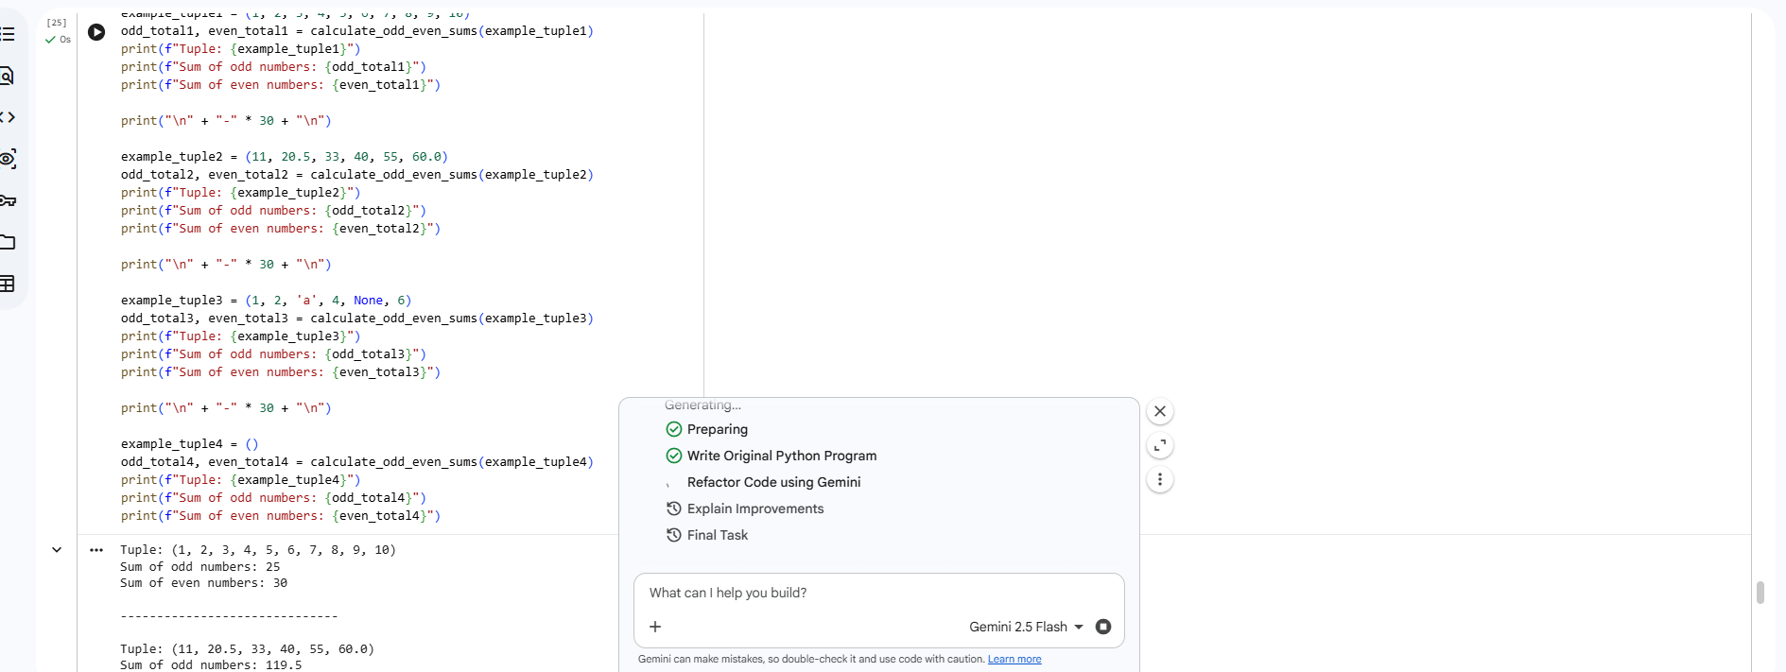
- 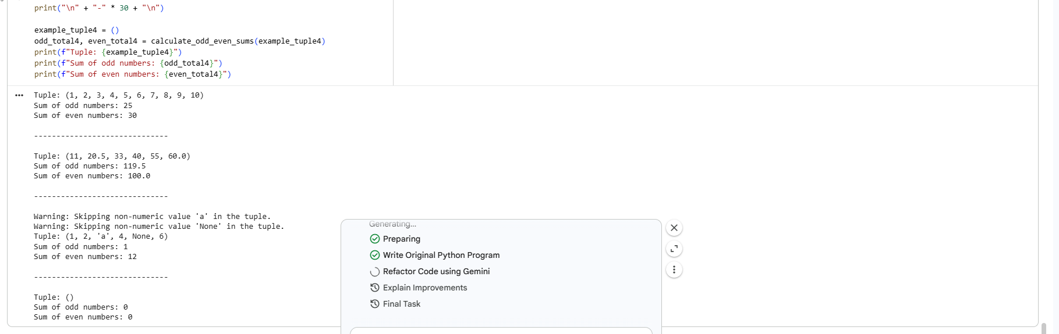
- 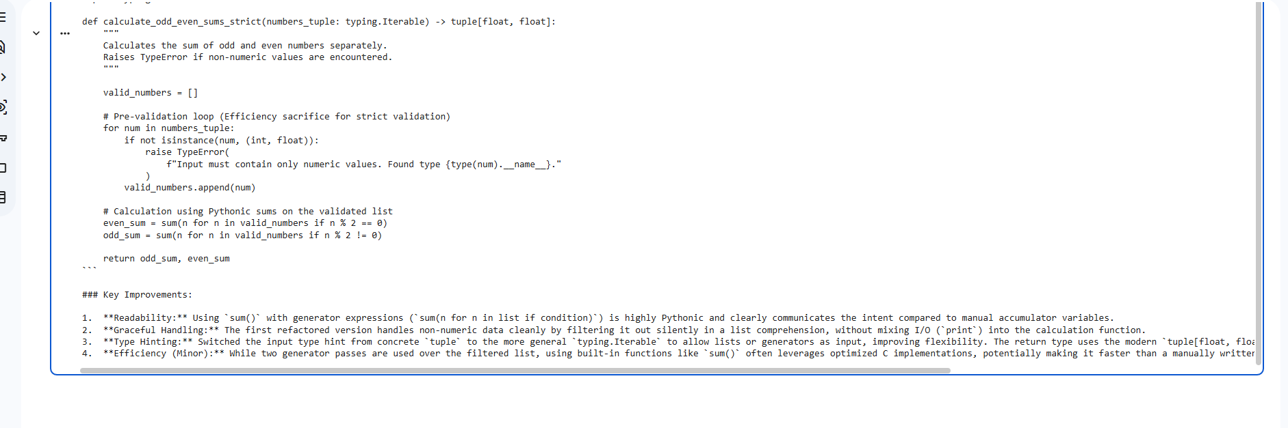
- 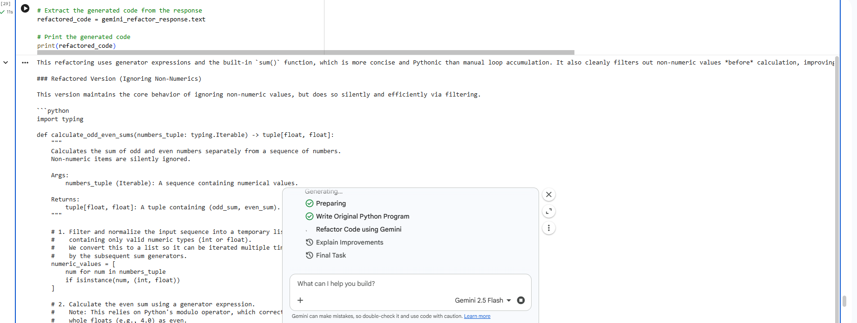
- 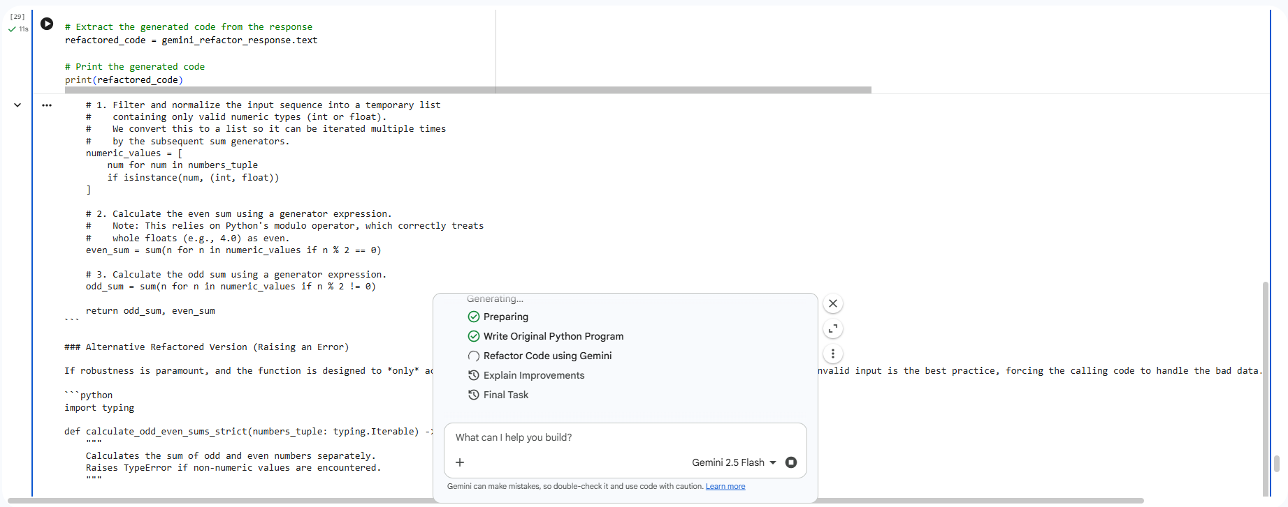
- Compare the original Python code with the Gemini-refactored code, highlighting and explaining the improvements made by the AI tool.
#### Instructions
1. Review the `refactored_code` variable which contains Gemini's generated refactored functions and its explanation of improvements.
2. Summarize the key improvements identified by Gemini, focusing on aspects like readability, graceful handling of non-numeric values, updated type hinting, and efficiency. Ensure to mention both the 'ignoring non-numerics' and 'raising an error' approaches provided by Gemini.
3. Clearly state how each improvement enhances the original `calculate_odd_even_sums` function.
### Explanation of Gemini's Refactoring Improvements
Gemini provided two refactored versions of the `calculate_odd_even_sums` function, each with distinct advantages, and a clear explanation of the improvements. Here's a summary of the key enhancements:
#### 1. Refactored Version (Ignoring Non-Numerics)
This version improves upon the original by:
* **Readability and Pythonic Style**: It leverages generator expressions with the built-in `sum()` function, making the code more concise and expressive than the original's manual loop accumulation. For example, `even_sum = sum(n for n in numeric_values if n % 2 == 0)` is highly readable.
* **Graceful Handling of Non-Numeric Values**: Instead of printing a warning inside the loop, which mixes I/O with calculation logic, this version filters out non-numeric values silently and efficiently using a list comprehension (`numeric_values = [num for num in numbers_tuple if isinstance(num, (int, float))]`). This separates concerns and makes the function cleaner.
* **Type Hinting**: The input type hint is changed from a concrete `tuple` to the more general `typing.Iterable`, increasing the function's flexibility to accept various sequence types (e.g., lists, generators). The return type also uses modern type hinting `tuple[float, float]`.
* **Efficiency (Minor)**: While it involves two passes (one for filtering, two for sums), using optimized built-in functions like `sum()` with generator expressions can often be more efficient than a manual Python loop, especially for large datasets.
#### 2. Alternative Refactored Version (Raising an Error)
This version offers a more robust approach, particularly when strict input validation is required:
* **Strict Error Handling**: Instead of silently ignoring non-numeric values or printing warnings, this version explicitly `raise TypeError` if any non-numeric value is encountered. This forces the calling code to handle invalid input, preventing unexpected behavior downstream. This is a significant improvement for data integrity and predictable function behavior, as the original only printed warnings.
* **Clearer API**: By raising an error, the function's API becomes clearer: it expects only numeric values, and anything else is an error. This is often preferred in library code or critical applications.
#### Summary of Key Improvements
* **Readability and Pythonic Idioms**: Gemini's refactoring utilizes Python's built-in `sum()` with generator expressions, making the code significantly more readable and aligned with Pythonic best practices compared to the original's explicit `for` loop and conditional accumulations.
* **Improved Non-Numeric Value Handling**: The original function used `print()` statements for warnings, which is generally undesirable within a pure function. Gemini provided two better strategies: silently filtering (more user-friendly for messy data) or explicitly raising a `TypeError` (more robust for strict data validation).
* **Enhanced Type Hinting**: The use of `typing.Iterable` for input and `tuple[float, float]` for return types makes the function signature more precise and flexible, aiding in static analysis and code understanding.
* **Modularity**: By separating the filtering of numeric values from the summation logic, the code becomes more modular and easier to maintain.
Overall, Gemini's refactoring significantly improved the original function's robustness, readability, and adherence to Python best practices, offering flexible solutions for different error-handling philosophies.

